 | Mehran University of Engineering and Technology, Khairpur  Department of Software Engineering

Course: SWE-Computer Network Practical
Instructor |  | Dr. Asad Raza Malik |  |  | Practical/Lab No. |  |  | 09
Date |  | 08-10-2024 |  |  | CLOs |  |  | 03
Student’s Roll no: |  |  |  |  | Point Scored:
Date of Conduct: |  | 08-10-2024 |  |  | Teacher’s Signature:
LAB PERFORMANCE INDICATOR | Subject Knowledge |  | Data Analysis and Interpretation | Ability to Conduct Experiment |  | Presentation | Calculation and Coding |  | Observation/ Result | Score

Topic | To configure the RIP dynamic routing protocol on two routers
Objective | - The objective of this lab is to configure the RIP (Routing Information Protocol) dynamic routing on two routers to enable communication between different network segments.  - Students will learn how to set up and verify RIP version 2, understand its behaviour in sharing routing information, and analyze the effectiveness of RIP in maintaining accurate routing tables.  - The lab aims to develop hands-on skills in implementing distance-vector routing protocols and troubleshooting basic connectivity issues in small to medium-sized networks.
Lab Discussion: Theoretical concepts and Procedural steps

What is Routing Information Protocol (RIP)
RIP (Routing Information Protocol) is a distance-vector routing protocol that is used to determine the best path to a destination within a network. It operates based on the hop count, where the path with the fewest number of hops to the destination is selected. Here's some theoretical information about configuring RIP on two routers:
Key Concepts of RIP:
- Distance-Vector Routing Protocol: RIP uses hop count as its routing metric to determine the best path. A hop is defined as a passage through one router. The maximum hop count allowed for RIP is 15, which limits its use to smaller networks.
- Routing Updates: RIP routers send their entire routing table to their directly connected neighbors every 30 seconds. This periodic update can lead to higher bandwidth usage on larger networks.
- Versions of RIP:
  - RIP Version 1 (RIPv1): It is classful, which means it does not support subnet masks in its routing updates.
  - RIP Version 2 (RIPv2): It is classless and supports subnet masks, VLSM (Variable Length Subnet Masking), and multicast routing updates.
  - RIPng (RIP next generation): This version of RIP is used for IPv6 networks.
- Timers Used in RIP:
  - Update Timer: Every 30 seconds, the router sends out its entire routing table to all its neighbors.
  - Invalid Timer: If a route is not updated within 180 seconds, it is marked as invalid.
  - Flush Timer: If a route is not updated for 240 seconds, it is removed from the routing table.
  - Hold-down Timer: When a route is marked as unreachable, this timer prevents any changes to the route for a specific period, usually 180 seconds.
Implementation of RIP Routing in Cisco for Connecting Two Routers
Steps to Configure and Verify Two Router Connections in Cisco Packet Tracer:
Step 1: First, open the Cisco packet tracer desktop and select the devices given below:
S. No | Device | Model Name | Qty.
1. | PC | PC | 4
2. | Switch | PT-Switch | 2
3. | Router | PT-Router | 2

IP Addressing Table
S. No | Device | IPv4 Address | Subnet-Mask | Default-Gateway
1. | PC0 | 192.168.10.2 | 255.255.255.0 | 192.168.10.1
2. | PC1 | 192.168.10.3 | 255.255.255.0 | 192.168.10.1
3. | PC2 | 192.168.20.2 | 255.255.255.0 | 192.168.20.1
4. | PC3 | 192.168.20.3 | 255.255.255.0 | 192.168.20.1

- Then, create a network topology as shown below the image.
- Use an Automatic connecting cable to connect the devices with others.

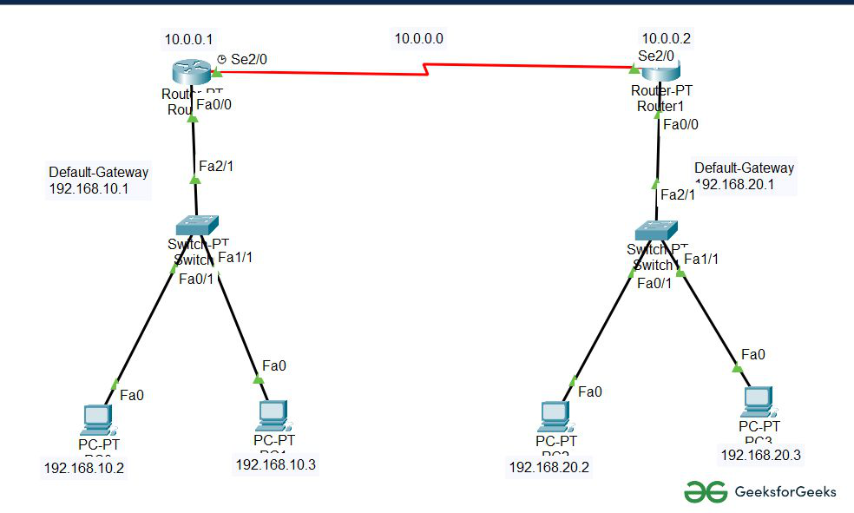
Step 2: Configure the PCs (hosts) with IPv4 address and Subnet Mask according to the IP addressing table given above.
- To assign an IP address in PC0, click on PC0.
- Then, go to desktop and then IP configuration and there you will IPv4 configuration.
- Fill IPv4 address and subnet mask.
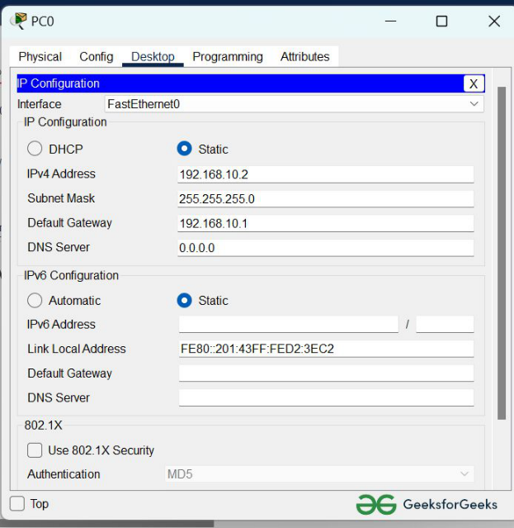

- Assigning IP address using the ipconfig command, or we can also assign an IP address with the help of a command.
- Go to the command terminal of the PC.
- Then, type ipconfig <IPv4 address><subnet mask><default gateway>(if needed)
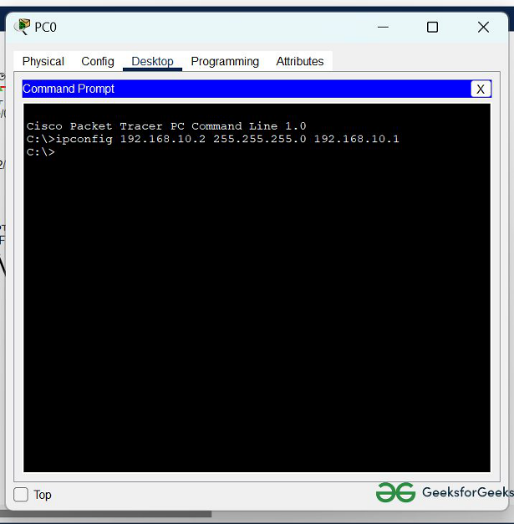

- Repeat the same procedure with other PCs to configure them thoroughly.
Step 3: Configure router with IP address and subnet mask.
IP Addressing Table Router
S. No | Device | Interface | IPv4 Address | Subnet Mask
1. | Router 0 | FastEthernet0/0 | 192.168.10.1 | 255.255.255.0
 |  | Serial 2/0 | 10.0.0.1 | 255.0.0.0
2. | Router 1 | FastEthernet0/0 | 192.168.20.1 | 255.255.255.0
 |  | Serial 2/0 | 10.0.0.2 | 255.0.0.0

- To assign an IP address in router0, click on router0.
- Then, go to config and then Interfaces.
- Make sure to turn on the ports
- Then, configure the IP address in FastEthernet and serial ports according to IP addressing Table.
- Fill IPv4 address and subnet mask.
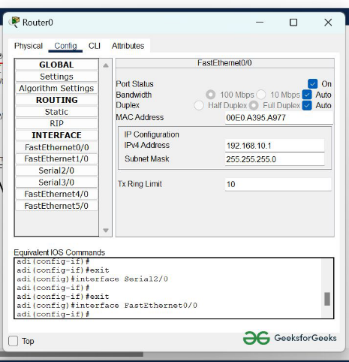

- Repeat the same procedure with other routers to configure them thoroughly.
Step 4: After configuring all of the devices we need to assign the routes to the routers.
To assign RIP routes to the particular router:
- First, click on router0 then Go to CLI.
- Then type the commands and IP information given below.
RIP Routes for Router0 are given below:
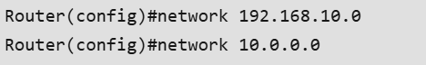
RIP Routes for Router1 are given below:
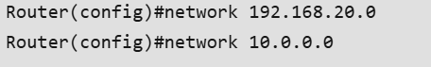
Step 5: Verifying the network by pinging the IP address of any PC.
we’ll use the ping command to do so.
- First, click on PC0 then Go to the command prompt
- then type ping <IP address of targeted node>
- as we can see in the below image we are getting replies which means the connection is working very fine
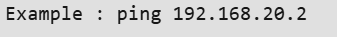
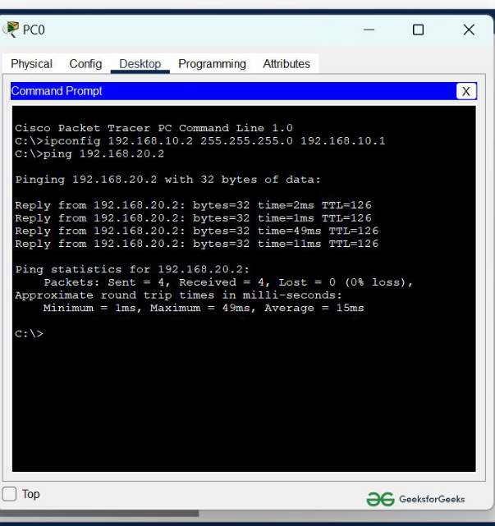

Assignment: Configuring RIP Dynamic Routing Protocol
Objective:
Configure RIP version 2 on two routers to enable communication between different network segments and verify the routing tables. Analyze how RIP dynamically updates routes and adapts to changes in the network topology.
Instructions:
- Network Setup:
  - Set up a network with two routers, Router A and Router B.
  - Connect Router A to a network segment (e.g., 192.168.1.0/24) and Router B to another network segment (e.g., 192.168.2.0/24).
  - Use a common link between the two routers, such as the 10.0.0.0/24 network.
- Configuration Tasks:
  - Assign appropriate IP addresses to all router interfaces.
  - Configure RIP version 2 on both Router A and Router B.
  - Specify the networks that should be advertised in the RIP protocol.
  - Save the configurations on both routers.
- Verification Tasks:
  - Use the show ip route command to view the routing tables on both routers.
  - Verify that the routes learned via RIP are present in the routing tables.
  - Use the debug ip rip command to monitor RIP update messages between the routers.
  - Simulate a network change (e.g., disconnect a link) and observe how RIP updates the routing tables.
- Analysis:
  - Analyze the behavior of RIP in terms of convergence time and how it responds to network changes.
  - Identify the limitations of RIP in terms of hop count and scalability.
  - Suggest scenarios where RIP would not be suitable and recommend alternative routing protocols for larger networks.
Submission Requirements:
- A screenshot of the routing table from each router.
- A brief report (1-2 pages) summarizing the configuration process, verification steps, and analysis of RIP's performance.
- Answers to the following questions:
  - How does RIP handle updates when a network link goes down?
  - What are the primary limitations of using RIP in modern networks?
  - How does RIP version 2 differ from RIP version 1?
Grading Criteria:
- Configuration (40 points): Correct setup and configuration of RIP on both routers.
- Verification (20 points): Proper use of commands to verify RIP operation.
- Analysis (30 points): Clear understanding of RIP's behavior and its limitations.
- Report Quality (10 points): Clarity, completeness, and organization of the report.

---END---

